PUBLIC HEALTH RESEARCH

How likely does the Microenvironnmental Interaction at a Pesticide-Treated Farming Village could Potentially Affect their Community through Dermal Pathway in a Developing Country, Malaysia?

How Vivien¹, Zailina Hashim¹ and Dzolkhifli Omar²

¹Department of Environmental and Occupational Health, Faculty of Medicine and Health Sciences, Universiti Putra Malaysia, Selangor, Malaysia.
²Department of Plant Protection, Faculty of Agriculture, 43400, Universiti Putra Malaysia, Selangor, Malaysia.

*For reprint and all correspondence: Dr. Vivien How, Department of Environmental and Occupational Health, Faculty of Medicine and Health Sciences, 43400, Universiti Putra Malaysia, Serdang, Selangor, Malaysia.
Email: vivien@upm.edu.my

ABSTRACT

Received | 7 May 2015
Accepted | 4 August 2015
Introduction | This paper aims to investigate the potential pesticide dermal contamination among the agricultural community by observing the microenvironmental and macroactivity interaction between farm children and adult farmer.
Methods | A 24 hours timeline activity was observed and recorded in the agricultural farming village, Kuala Selangor. In this study, 2 homes were monitored for 2 days following a pesticide application. A total of 2 adult farmers and 5 children (7-10 year old) were recruited to participate in this study. Twenty-four hour videotape segments and time-activity diaries were collected during the study.
Results | The microenvironment and macroactivity interaction were modelled in this study. By considering only the potential dermal exposure pathway, the different biological vulnerability and exposure pattern to pesticides were observed. Finding showed a greater extent of interaction between human and its environment, where adult farmers are the main contributor of environmental contaminants, and children is one of the vulnerable receivers of the contaminants’ residuals from the environment.
Conclusion | The daily activities and behaviors practiced by the agricultural community were among the contributing factors which help to highlight the pesticide dermal contamination pathway in the farming village. This study recommends the necessary to consider the microenvironment and macroactivity of the target community when assess their exposure levels to the environment contaminants.
Keywords | Dermal exposure - Microenvironment interaction - Pesticide - Children and adult.

INTRODUCTION
Skin exposure to chemical substances is widely known to contribute significant dose in many workplace situations. Its relative importance is increasing when airborne occupational exposure limits are reduced, particularly to OP pesticides which disintegrate quickly in air and light.¹⁻² In view of this, past studies asserted that dermal route represented >99.0% of the total exposure among farmers applying pesticide with their backpack spraying devices.³⁻⁴ Nevertheless, the concern for dermal exposure does not end in the workplace. Pesticides may build up on surface such as carpets, walls, and counters insider homes and building regularly used by the community, such as schools, day care centers, and public. This may be associated with a number of different environmental media including water, soil, sediment, and consumer products.⁵
Since children and adult from different environmental background are at different risk of up-taking pesticide through the skin, Figure 1 demonstrates the potential dermal exposure pathway from the pesticide treated farm. It shows that the mixture of pesticides was absorbed into the soil and leaches into groundwater through pesticide runoff and its spray drift. It is possible for pesticide to land on or be absorbed into the skin directly from the air.² In other words, these pesticide residues may be transferred to the skin from contact with the contaminated surfaces or by submersion of body parts into the substance through different dermal exposure pathway among the children and adult.
In adults, dermal exposure more likely to occur while mixing and loading the pesticide, cleaning the equipment and disposing the empty containers to avoid cross-contamination. Besides, the condition of workers’ protective gear might also serve as an additional exposure pathway.^{3, 6-7} Nonetheless, children appear to be particularly vulnerable to the effects of pesticides as they have less developed detoxification pathway and larger body surface area and volume of the skin.⁸ In fact, due to their age- and gender-related exposure pattern, children who live in the agricultural community are inevitable from exposure to pesticides from their indoor and outdoor activity.⁹⁻¹⁰ Therefore, this paper aims to investigate the potential pesticide dermal contamination among the agricultural community by observing the microenvironmental and macroactivity interaction between farm children and adult farmer.

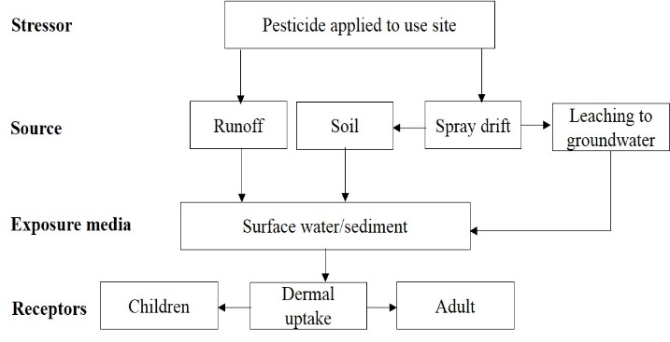
Figure 1 Dermal exposure pathway from pesticide treated farm.¹¹

MATERIALS AND METHODS
In this study, 2 homes from the agricultural farming village of Kuala Selangor were monitored for 2 days following a pesticide application. Twenty-four (24) hours videotape segments and time-activity diaries were collected during the study. A total of 2 adult farmers and 5 children (7-10 year old) were recruited to participate in this study. Specific macroactivity and microenvironment combinations for both the adult farmer and their children were determined from the videotape segments and the time-activity diaries. The purpose of this method is to assess the community’s exposure to pesticides by considering the microenvironment/ macroactivity interaction. With this approach, both the adult farmer and their children’s exposure to chemicals are observed for each microenvironment where they spend time and each macroactivity that they conduct within that specific microenvironment.¹²

RESULTS
The aggregate exposure is modelled by combining both the microenvironment/ macroactivity interaction as shown in Figure 2. By considering only the potential dermal exposure pathway, the different biological vulnerability and exposure pattern to pesticides were observed. Finding showed a greater extent of interaction between human and its environment, where adult farmers are the main environment contaminants’ contributor, and children are one of the vulnerable receivers of the contaminants’ residuals from the environment.

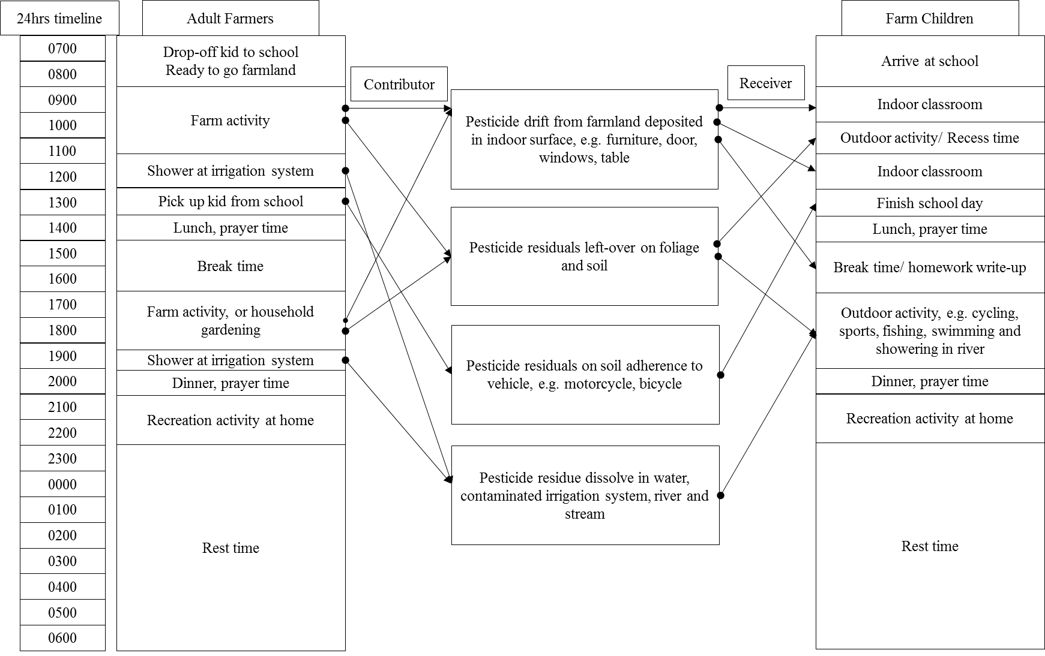Figure 2 A 24 hours timeline among studied farming community

DISCUSSION
Since the environment-surface-skin transfer contamination and consecutive absorption is a complex process¹³, the mechanism of pesticide transport from an exposure sources to the skin surface and their subsequent absorption into the body is of concerned.¹⁴⁻¹⁵ Therefore, this study assumes that an additive effect occurs when a mixture of pesticide was deposited into the skin. For instance, pesticide droplet from the spraying drift may retain on foliage as pesticide residues, or can be transferred to the body surface during the subsequent dermal contact through water and soil by adult and children.¹⁶ Besides, due to insufficient data on the total mixture of pesticide used, study presumes that 100% of the effective surface loading of pesticide has been dissolved in water and soil.

The Adult Farmer’s Microenvironment/ Macroactivity
Workplace skin contamination can occur as a result of fall-out from aerosols, via direct immersion into the chemical, as a result of accidental spills onto the body, through vapor penetration of the skin, or from contact with contaminated surfaces.⁵To date, its relative important is increasing when airborne occupational exposure limits are reduced, such as organophosphate pesticide which could disintegrate quickly in the air and under light exposure but pesticide residues can remain for days, weeks and months in environmental surface. ^{1-2, 23}
This study observed that young adult (15 year old) spent his after school hours to help in the farmland which was viewed as a way of life to support and keep the family’s land and asset. This situation was widely being practiced among family-based agricultural community in developing country like Malaysia²⁵ Therefore, young adult are likely to expose to pesticide from their indoor school and home environment, as well as from the outdoor pesticide-treated farmland and during recreational activity. Besides, adult farmers (>18 years) who spent most of their time outdoors in the farmland are seen as the main contributing factor for the subsequent pesticide contamination through dermal pathway via water and soil to the agricultural community. In fact, farmers are also unavoidable from direct dermal contamination when handling with pesticides or re-entering pesticide-treated farmland. ^{6, 25}
The video segmental also recorded that, farmers who received an amount of pesticide attached to their protective clothes, might cross-contaminate his protective clothes, might cross-contaminate his protective gear into the nearby furrow irrigation system which then dissolved pesticide residues in soil or water. He then travels home or to school to pick up his children with his vehicle adhered with soil contaminated with pesticide from spray drift. Once they arrive home, “take-home pathway” occur as both adults and children brought the residuals from outside. In addition, contaminated furrow irrigation might either returning to rivers and streams from drainage water, or percolates through the soil and returns to a river or back to the household water supply system.

The Children’s Microenvironment/ Macroactivity
It is known that children who live in proximity to the pesticide-treated farmland are facing the considerable effect of low-level and cumulative pesticide exposure.¹⁶⁻¹⁸This is due to the fact that, children are physiologically different from that of an adult in response to the environmental toxicants.¹⁹⁻²⁰ Children internal organs are still developing and maturing. Their enzymatic, metabolic, and immune systems may provide less protection than an adult. Under this continuous environmental stress, children become vulnerable to this environmental contaminant as compared to adults. 8
During video segmental analysis, pre-children was observed as the susceptible group due to their small body mass (relative to dose) which caused them become vulnerable when exposed to pesticide through mouthing objects, crawling near to the floor where the pesticide residuals settled and etc.^{10, 17} The outdoor-type children who is physically active for their outdoor activity, such as rolling on the grass, hide or play in the bush, and slide or tumble around the field are viewed as the high risk group of receiving the pesticide residues or droplet drifted from nearby farming areas.
In addition, dermal exposure from the indoor environment (e.g. day care center, school, and classroom) is viewed as another important exposure pathway. In fact, once in an indoor environment, pesticides’ breakdown rate become slowly, where the residues may be protected from direct sunlight, rain, temperature variation and microbial action.^{17, 21-22}As a result, children may be more exposed to pesticides through normal daily activities after a residential pesticide application within the home.¹²

CONCLUSION
This study provides a platform of discussion for the potential pesticide dermal contamination through environmental and occupational exposure by the children and adult when considers their microenvironment/macroactivity pattern. The daily activities and behaviors practiced by the agricultural community were among the contributing factors which help to highlight the pesticide dermal contamination pathway in the farming village.

ETHICAL CONSIDERATION
This study has obtained the ethical clearance from the Medical Research Ethics Committee, Faculty of Medicine and Health Sciences, University Putra Malaysia. A written consent has also been obtained from all respondents and the confidentiality was maintained throughout the study.
Ethical issues (Including plagiarism, Informed Consent, misconduct, data fabrication and/or falsification, double publication and/or submission, redundancy, etc.) have been completely observed by the authors.

ACKNOWLEDGMENT
The author thanks to both the adults and children who voluntarily participated in this study.

REFERENCE
- Fenske RA. Dermal exposure assessment techniques. Ann OccupHyg. 1993; 37(6): 687-706.
- Schneider T, Vermeulen R, Brouwer DH, Cherrie JW, Kromhout H, Fogh CL. Conceptual model for assessment of dermal exposure. Occup Environ Med. 1999; 56(11):765-73.
- Blanco LE, Aragon A, Lundberg I, Wesseling C, Nise G. The determinants of dermal exposure ranking method (DERM): a pesticide exposure assessment approach for developing countries. Ann OccupHyg. 2008; 52(6):535-44.
- Machera K, Kapetanakis E, Charistou A, Goumenaki E, Glass RC. Evaluation of potential dermal exposure of pesticide spray operators in greenhouses by use of visible tracers. J Environ Sci Heal B. 2002; 37(2):113-21.
- Ness SA. Assessment of Community Exposures- Surface and dermal monitoring for toxic exposure, New York; Van Nostrand Reinhold, 1994: 120-150.
- Kapka-Skrzypczak L, Cyranka M, Skrzypczak M, Kruszewski M. Biomonitoring and biomarkers of organophosphate pesticides exposure - state of the art. Ann Agric Environ Med. 2011; 18(2): 294-303.
- Van-Wendel-de-Joode B, Brouwer DH, Vermeulen R, Van Hemmen JJ, Heederik D, Kromhout H. DREAM: a method for semi-quantitative dermal exposure assessment. Ann OccupHyg. 2003; 47(1):71-87.
- Bearer CF. How are children different from adults? Environ Health Persp, 103 Suppl. 1995; 6:7-12.
- Arcury TA, Grzywacz JG, Barr DB, Tapia J, Chen H, Quandt SA. Pesticide urinary metabolite levels of children in eastern North Carolina farmworker households. Environ Health Persp. 2007; 115(8):1254-60.
- Carozza SE, Li B, Wang Q, Horel S, Cooper S. Agricultural pesticides and risk of childhood cancers. Int J HygEnvir Heal. 2009; 212(2):186-95.
- Brady DJ. Guidance for the development of conceptual models for a problem formulation developed for registration review [Memorandum]. United State Environmental Protection Agency (USEPA)[Serial online]. 2011.
- Tulve NS, Hore P, CohenHubal EA, Freeman NG, Lioy PJ, Sheldon LS. Assessment Of Young Children's Potential Pesticide Exposure Following A Residential Pesticide Application. Part II - Use Of The Macroactivity Approach. Presented at ISEA 2000 Exposure Analysis in the 21st Century: Integrating Science, Policy and Quality of Life, Monterey Peninsula, CA, October 24-27, 2000.
- U.S. Environmental Protection Agency (USEPA). Risk Assessment Guidance for Superfund (RAGS) Supplemental Guidance for Dermal Risk Assessment (Part E) (Report No. EPA/540/1-89/002). [Serial online]. 2004. Available from: http://www.epa.gov/oswer/riskassessment/ragse/. Accessed June 20, 2013.
- Hubal EAC, Egeghy PP, Leovic KW, Akland GG. Measuring potential dermal transfer of a pesticide to children in a child care center. Environ Health Persp. 2006; 114(2):264-9.
- Aragon A, Blanco L, Lopez L, Liden C, Nise G, Wesseling C. Reliability of a visual scoring system with fluorescent tracers to assess dermal pesticide exposure. Ann OccupHyg. 2004; 48(7):601-6.
- FenskeRA, and Day EW. Assessment of exposure for pesticide handlers in agricultural, residential and institutional environments. In: Occupational and residential exposure assessment for pesticides, Franklin, C.A.W. (Eds.), John Wiley & Sons, Ltd, Chichester, U.K, 2005: 13-41. ISBN: 9780471489894.
- Mattews GA. Spray drift, bystander, resident and worker exposure. In: Pesticides: Health, safety and the environment. Blackwell, Oxford, 2006. ISBN-10: 1405130911.
- Beamer PI. Pesticide exposure of farmworkers' children. In: Pesticide in the modern world-effects of pesticides exposure, Stoytcheva, M, (Eds.), InTech, Europe, 211: 80-100. ISBN: 9789533074542.
- Curl CL, Fenske RA, Kissel JC, Shirai JH, Moate TF, Griffith W, et al. Evaluation of take-home organophosphorus pesticide exposure among agricultural workers and their children. Environ Health Persp. 2002; 110(12):A787-92.
- Garry VF. Pesticides and children. ToxicolApplPharmacol. 2004; 198(2):152-63.
- Neri M, Ugolini D, Bonassi S, Fucic A, Holland N, Knudsen LE, et al. Children's exposure to environmental pollutants and biomarkers of genetic damage. II. Results of a comprehensive literature search and meta-analysis. Mutat Res. 2006; 612(1):14-39.
- Lu C, Fenske RA, Simcox NJ, Kalman D. Pesticide exposure of children in an agricultural community: evidence of household proximity to farmland and take home exposure pathways. Environ Res. 2000; 84(3):290-302.
- McCauley LA, Lasarev MR, Higgins G, Rothlein J, Muniz J, Ebbert C, et al. Work characteristics and pesticide exposures among migrant agricultural families: a community-based research approach. Environ Health Persp. 2001; 109(5):533-8.
- Riley B. Unthinkable risk: How children are exposed and harmed when pesticides are used in school (Technical Report). Eugene: Northwest Coalition for Alternatives to Pesticides, 2000.
- Larson NC, Dearmont M. Strengths of farming communities in fostering resilience in children. Child Welfare. 2002; 821-35.

