DEVELOPMENT OF CONSTRUCTION WASTE MANAGEMENT FRAMEWORK FOR REFURBISHMENT PROJECTS
Norfadhillah Binti Yahaya¹, Azlan Shah Bin Ali²
1Public Works Department of Malaysia, Kuala Lumpur
2Faculty of Built Environment, University of Malaya, 50603, Kuala Lumpur, Malaysia.
*Corresponding author: alidyila11@gmail.com

Abstract

The high demand of building refurbishment creates an increase in construction waste. Construction waste has been associated with a negative impact on the performance of refurbishment projects such as delay and over budget. Therefore, construction wastes in refurbishment projects have been identified as an important issue to improve the waste management of the refurbished building. The main objective of this paper is to establish a relationship between the causes of construction waste towards cost and time overruns. This study further analysed the mitigation measures that can minimise construction waste. The primary data were obtained using questionnaire surveys that were distributed among quantity surveyors, in Peninsular Malaysia, who oversee refurbishment projects. Through an extensive literature review, both qualitative and quantitative data were employed. A set of questionnaire surveys was initially conducted for sixty-five (65) projects, followed by semi-structured interviews for five (5) interviewees, so as to validate the critical causing factor and to establish a correlation between the factors. The obtained data were then analysed using the ‘Statistical Package for Social Science’ (SPSS). The inferential analysis method through Spearman correlation test was applied to test all correlations in this study, while the descriptive analysis was used to evaluate the demographic of the respondents. The results indicated a significant relationship between the causes of material waste and the performance of refurbishment projects. The analysis revealed that design changes, poor storage and improper packaging are the most prominent factors that cause material waste. These causes demonstrate a significant correlation with the performance of refurbishment projects. On the other hand, proper storage, the handling of materials on site and good construction management were identified as not significantly correlated, however, they possess high potential for mitigation measures. Therefore, an integrated refurbishment waste framework was established, which involved the causes-effect correlation, as well as, the mitigation measures for solving it.

Keywords:
Waste Management, Construction, Refurbishment

Article history:
Submitted: 23/11/2017; Revised: 21/2/2018; Accepted: 26/03/2018; Online: 1/06/2018

BACKGROUND OF STUDY

Refurbishment projects have been identified as an important sector in the construction industry due to existing and high presence of building deterioration, the increasing number of aged buildings and building obsolescence. Refurbishment work has fundamentally increased in the last quarter century in the UK. Egbu (1998) observed, from DOE (1981) and CCCIS (1996) that refurbishment work had escalated from 22.46% to 42.32% from the total UK construction output between 1981 to 1996. Ali et al. (2008) stated that the growing number of old buildings, along with rapidly changing innovations in Malaysia’s development, required modification so as to facilitate the current utilisation of buildings. Thus, this indicated that refurbishment is a popular sector compared to other sectors in the construction industry. However, builders in the construction industry have shown poor waste management practices. This was reported by Intan (2005), who studied on construction waste management of 13 projects in Surabaya, Indonesia. The report stated that materials on site were 12.51% badly selected (resulting in fragile and crushed materials during handling and execution), 11.39% of poor management of material operations and 4.67% of poor practices in waste management. Furthermore, the project team and workforce have both inadequate knowledge and lower readiness for addressing the construction waste issue (Gavilan and Bernold, 1994). These circumstances tend to impact the performance of construction achievements.

Malaysia has fallen into the construction waste problem in parallel to the substantial growth of refurbishment projects. The CIDB (2015) reported that in year 2006 refurbishment constituted 16% of total Malaysian construction output and rose up to more than 25% in 2014. With the increasing demand of building obsolescence and old buildings, large amounts of construction waste are being produced in Malaysia. This issue remains unresolved and uncertain. Several authors had reported numerous facts, such as Begum et al. (2006), who noted that 28.34% of the total waste sent to landfills in Malaysia originates from construction activities. The Malaysian construction industry, particularly refurbishment tasks, had conducted several projects that did not achieve the target cost and time effectiveness. Since the performance of refurbishment projects are based on the performance factor, as stated earlier, construction waste has been identified as the main problem. Contractors are responsible for handling construction waste on site. However, there is no systematic procedure of monitoring and supervising by the project manager. Therefore, plenty of wastes have been left unattended on-site, and improper management ensued for handling such waste (Liong, 2017). Wastes have a negative impact on the efficiency of the refurbishment project’s performance. Ali et. al. (2008) supported by stated that refurbishment projects are uncertain in terms of time performance and cost within budget. Thus, the main aim of this paper is to investigate the relationship between the causes of construction waste on cost and time performance.

LITERATURE REVIEW

Factors Contribute To Construction Waste

Dainty & Brooke (2004) mentioned that a significant source of waste is from the very late adjustment and alteration to the building design. This results in construction material waste due to surplus order, left-over materials because of wrong gauge, bundling waste, non-reclaimable consumables, poor stockpiling practices, material handling that cause material deterioration and inadequate assurance of the completed work. The sources of waste were identified in two phases in the construction industry; namely, pre-construction and post construction phases. Generation of construction waste is throughout the entire process of the project including the pre-construction stage, construction stage and the completion of the work stage. Chun-Li et al. (1997) and Liong (2017) agreed that various factors contribute to production of construction waste, as follows:

1. Design changes

2. Rework

3. Poor supervision

4. Poor storage

5. Poor workmanship

6. Material handling

7. Equipment

8. Weather

9. Theft and vandalism

10. Inappropriate specification

11. Inadequate worker skill

12. Damaged material on site

13. Over ordering

14. Improper packaging

15. Poor design

Refurbishment Project Performance

Cost and time are vital issues in project management, also viewed as the most critical issues for measuring the target goal of the refurbishment project (Nagapan et al., 2012). Poor performances of cost and time have a direct impact on the contract cost, causing delays to the project. Thus, the project will be unsuccessful, and the client unsatisfied.

The word ‘cost’ is considered to be the most crucial aspect for the success of any project performance in a construction project. A successful project is defined as achievable when the technical performance is good, following the schedule and creating value for money (Frimponga et al., 2003). Azhar et al. (2008) stated that the issue of cost overrun in construction projects is prevalent in both developed and undeveloped countries. However, these developments are extremely critical issues in undeveloped countries where such cost overruns exceed 100% of the total cost.

Time overruns occur during the first and last stages and may affect the time of project completion. There are various authors who indicated factors that cause time overruns. Nagapan et al. (2012) stated that four factors cause time overruns; namely, contractor-related factors, consultant-related factors, client-related factors and external factors. On the other hand, Fugar et al. (2010) indicated five factors that cause time overruns, which include changing orders, slow decision-making by clients, lack of capability of client representative, construction financial difficulties, and late delivery of materials. Based on the literature review above, a simple conceptual framework could be developed as follows:

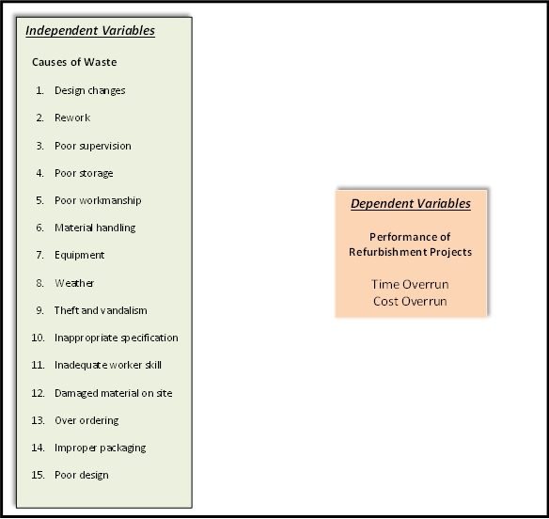

Figure 1: Conceptual Framework

Source: Developed based on Chun-Li et al. (1997) and Liong (2017)

RESEARCH METHODOLOGY

Refurbishment construction waste framework was developed from a literature review of Theoretical Frameworks for Refurbishment Project Waste. Sixty five (65) refurbishment projects with the minimum contract value of RM500,000 involved to form a database for analysis. Refurbishment Construction Waste Framework in Figure 2 was established to test the significant correlation between independent and dependent variables. The semi-structured interviews with five (5) respondents from construction waste professionals were conducted.

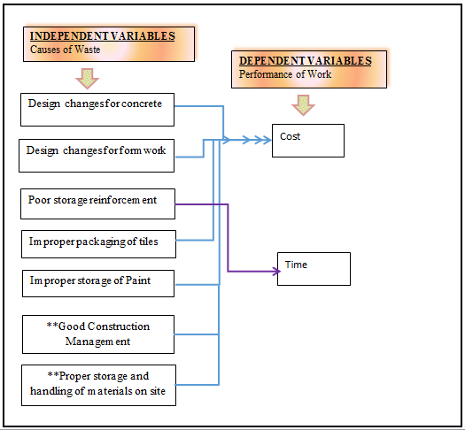

Figure 2: REFURBISHMENT CONSTRUCTION WASTE FRAMEWORK

This model was concerned with the correlation between cause and effect of construction waste on the performance of refurbishment projects. The connection between the causes (design changes in concrete, design changes in formwork, improper packaging of tiles and poor storage of paint) and effects (time and cost of refurbishment projects) were integrated to one relationship model. These variables indicated a strong significant relationship between both factors. This addressed a gap in the literature by providing a complete model within the context of relationships in the construction waste field.

RESULTS AND DISCUSSION

The intervening variables worked to reduce the negative outcomes of material waste causes on performance of refurbishment projects, which require further study. This is because most variables do not have a significant correlation between the independent variables and the dependent variables. However, variable ‘proper storage and handling of materials on site’, and ‘good construction management practice’ revealed that there is no significant correlation, but high potential to mitigate the problem.

The semi-structured interview with five (5) respondents agreed that this scenario happened due to unspecified materials for the main component of material waste, such as grading and types of material waste. Besides, they agreed that poor awareness leads to lower waste minimisation. This result indicated that respondents (quantity surveyors) have low awareness on the mitigation measures of construction waste. The interviewees further added that only a few quantity surveyors are really concerned with the issue of construction waste that affects the performance of the project. The training programmes would not be comprehensive to all staff in the Public Work Departments. Those who attend the construction waste course are only applicable for a few departments. There are cases where staffs who are aware of mitigation measures, but they do not implement them during refurbishment projects. To minimise the problem, the quantity surveyors must understand the concept of construction waste and be aware of the minimisation strategies.

CONCLUSIONS

The research briefly discussed the analysis findings based on the objective study. The main objectives are achievable through a correlation analysis. However, from the findings it was found that construction wastes of refurbishment tasks were from the perspectives of quantity surveyors. Quantity surveyors play an important role of monitoring the contractor’s project through an observation of the progress report, procurement, etc. However, the findings showed that quantity surveyors do not directly manage the site. The findings indicated a low awareness on mitigation measures of construction waste, and limited courses on waste were not accessible to all staff, and with very limited knowledge sharing. Therefore, low awareness signifies low mitigation measures. Refurbishment construction waste framework was created from the correlation analysis between two constructs (dependent and independent variables). The semi-structured interviews were conducted to validate the analysis findings extracted from the questionnaires.

References
Ali, A.S., Rahmat, I. and Hassan, H. (2008). Involvement of key design participants in refurbishment design process, Facilities. Emerald, UK. Vol. 26 No. 9/10 pp 389-400
Azhar, N., Farooqui, R.U. and Ahmed, S.M. (2008) Cost Overrun Factors in Construction Industry of Pakistan. Proceedings of the 1st ICCIDC-I Conference, Karachi, 4-5 August 2008, 499-508
Begum, R.A., C. Siwar, J.J. Pereira and A.H. Jaafar (2006). A benefit-cost analysis on the economic feasibility of construction waste minimization: The case of Malaysia. Resour. Conserv. Recycle.,48: 86-98.
CIDB (2015). Annual Report 2015. CIDB, Malaysia.
Chun-Li P., Domenic E.S. and Charles J.K. (1997): “Strategies for successful construction and demolition waste recycling operations”, Proceeding of Construction Management and Economics no.15, pp. 49-58
Fugar, F.D.K. and Agyakwah-Baah, A.B. (2010) Delays in Building Construction Projects in Ghana. Australasian Journal of Construction Economics and Building, 10, 103-116
Frimpong, Y., Oluwoye, J., & Crawford, L. (2003). Causes of delay and cost overruns in construction of groundwater projects in a developing countries; Ghana as a case study. International Journal of Project Management, 21(5), 321-326
Gavilan R.M. and Bernold L.E. (1994). Source evaluation of solid waste in building construction. J Construction Engineering Management, 120:536-52.
Intan, S., Ratna S.A. and Lie A. (2005). Analisa Dan Evaluasi Sisa Material Konstruksi: Sumber Penyebab, Kuantitas, Dan Biaya, Civil Engineering Dimension, Vol. 7, No. 1, 36-45, Thomson GaleTM
Liong, C.K. (2017) Determining Waste Generation Factors In Klang Valley Refurbishment Projects. Unpublished Master Dissertation, University of Malaya
Nagapan, S., Ismail, A.R., Ade, A., Aftab, H.M., Rosli, M.Z. (2012). Identifying Causes of Construction Waste- Case of Central Region of Peninsula Malaysia. International Journal of Integrated Engineering, Vol. 4 No. 2, pp. 22-28.

