POST OCCUPANCY EVALUATION TOWARDS FACILITIES IMPROVEMENT FOR STUDENTS WITH DISABILITIES IN UNIVERSITY OF MALAYA
Noor Aqmar Mohd Rusly¹, Syahrul Nizam Kamaruzzaman²
1,2Centre for Building Construction and Tropical Architecture, Faculty of Built Environment, University of Malaya, 50603, Kuala Lumpur, Malaysia.
*Corresponding author: syahrulnizam@um.edu.my

Abstract

Post Occupancy Evaluation or POE is a diagnostic tool used by Facility Manager to evaluate facilities performance in a building and as a tool to indicate satisfaction level of the user with existing facilities. Facilities management benefit from POE in gathering data and information about facilities performance, analysing data and also in making recommendations for facilities improvement. POE carried out in one of the library building at University of Malaya has determined which facilities need improvements and level of satisfaction have obtained from the students with disability as the end user of the facilities. Level of satisfaction and feedback from them were helpful for the improvement of current facilities at the library building. A questionnaire, interviews and observation instrument was used as the method to meet the objectives of the study. Furthermore, the design of the facilities at the library was compared against the Malaysian Standard guidelines in order to improve the facilities. Through this study, recommendations were made for facilities improvement for students with disability for short term, medium term and long term to the best value for money.

Keywords:
Post-occupancy evaluation, Facilities management, Disability, University of Malaya, Malaysia.

Article history:
Submitted: 25/1/2018; Revised: 23/03/2018; Accepted: 26/03/2018; Online: 1/06/2018

BACKGROUND OF STUDY

Post Occupancy Evaluation (POE) is an activity that originated from an interest regarding the performance of a building upon occupied (Federal Facilities Council, 2002). Baird et al. (1996) define POE as a generic term for various general programs, procedure, and specific techniques to evaluate how existing building facilities match with the occupant’s daily activities and needs. This tool requires systematic evaluation on occupants’ feedback about their daily experience in the building, however, Preiser et al. (1988) suggested that POE can only be done when the building has been built and been occupied for a period of time. According to Marans and Spreckelmeyer (1981), POE can be initiated by research, as a case study for a specific condition (Brill et. al, 1985) and to meet the need of an institutional for useful feedback on building and building-related activities (Farbstein and Kantrowitz, 1989). Meir et al (2009) suggested that the tools used for POE activity includes monitoring the performance of a building and surveys such as observational survey and questionnaire survey. According to Adriaanse (2007), the response feedback from the building users is often considered as a criteria for assessing the building performance quality. Therefore, this study will investigate the performance quality of the Main Library in the University of Malaya to identify the satisfaction level of the building users by questionnaire and observational survey. However, this study specifically focuses on the satisfaction level of students with disability towards the Main Library in order to identify the criterion needed of a person with disability.

LITERATURE REVIEW

Persons with Different Abilities

Persons with different abilities or Persons with disabilities, have difficulties to overcome in their daily life, as Centres for Disease Control and Prevention (2016) said, barriers could be more frequent and have greater impact to persons with disability, than individuals without. The United Nation (UN) Convention on the Rights of Persons with Disabilities (2012), or in short CRPD describe a person with disability as a person who suffers from “long-term physical, intellectual, mental, or sensory impairments which in interaction with various barriers may hinder their full and effective participation in society on an equal basis with others.” The CRPD (2014) stated that disability is not limited to being in a wheelchair but also include visual impairment, hearing impairment, intellectual disability, and mental disability. The CRPD (2014) listed four different approaches to disability and they are the charity approach, medical approach, social approach, and the human right approach. One of the general principles of human right approach as suggested by the CRPD is accessibility. They further define accessibility as “dismantling the barriers that hinders the effective enjoyment of human right by persons with disabilities; enables persons with disabilities to live independently and to participate fully in all aspects of life (CRPD, 2014).” The CRPD refers accessibility to all aspects of life, and specifically stressed on the physical environment such as accessibility to roads, housing, and buildings. Therefore, it is important to build a building that are disabled-friendly that allow easy access for persons with disabilities.

This study will investigate the facilities in and around the Main Library of University of Malaya in order to identify the friendliness of the library environment towards the students with disabilities. This research uses the Malaysian Standard (MS) Universal design and accessibility in the built environment – Code of Practice (MS 1184:2014) handbook as a guide and references. The Department of Standards Malaysia has prepared the Malaysian Standard to “adopt and promote standards, standardisation, and accreditation as a means of advancing the national economy, promoting industrial efficiency and development, benefiting the public health and safety… (The Department of Standards Malaysia, 2014).” Thus, the facilities and infrastructure of the Main Library will be evaluated and surveyed as according to the MS 1184:2014 in order to identify any improvements and upgrades needed to be done in order to meet the requirement of the students with disabilities and the standard set by the Department of Standards Malaysia.

RESEARCH METHODOLOGY

The objective of this research is to determine the users, specifically students with disability’s satisfaction towards facilities provided at a chosen library in the University of Malaya and the improvements to be made by using Post Occupancy Evaluation (POE). Thus, methods like a literature review, survey, and interview were being used in to assist this study. A literature review were conducted to understand POE and how it works. More, the literature review explores the topic of disability and building facilities through mediums such as journals, articles, professional and industries website, as well as rules and regulations, previous case studies, and official guidelines that are related to the study.

Next, two types of surveys were conducted, which are; observation survey and questionnaire survey. Observation survey was conducted and recorded to observe the library’s existing facilities and their condition. Moreover, observation survey helps to identify the adequacy and/or inadequacy of the facilities for the use of students with disability. This observation survey was conducted with the reference to “Malaysian Standard (MS) 1184:2014: Universal design and accessibility in the built environment – Code of Practice” by the Department of Standards Malaysia. Then, a set of questionnaires were distributed to a list of students with disability to obtain their feedbacks and satisfaction level towards the facilities provided. At the same time, an informal interview with the participated students with disability was conducted to attain the students’ ideas and opinions on facilities improvements to be made for a better disabled-friendly infrastructure. Finally, the data collected are then recorded, discusses, and analysed. SPSS software was used to analyse the data obtained from the questionnaires.

RESULTS AND DISCUSSION

A total of 50 sets of questionnaires distributed to the students with disabilities in the University Malaya, however, only 40 sets were returned, where 70% of them are males with 30% females. There are three disabilities identified, where; i) 65% are visually impaired, ii) 30% are physically impaired, and only iii) 5% are hearing impaired. Majority of the visually impaired students uses canes while physically impaired uses wheelchair or crutches, and the hearing-impaired students’ use hearing aid to assist their disabilities. 70% of the participants pointed out that the main entrance of the library needs to be improved, followed by lift area (15%), toilet (10%), and staircase area (5%). Furthermore, the participants have voted their top four important facilities that they need, that are: i) 50% of them voted guiding blocks, followed by ii) signs and symbols (35%), ramp, and handrail with 7.5% votes respectively.

Figure 1 shows the results of the facilities that are needed the most from the perspective of the respondents from the questionnaire survey. The respondents rated guiding block (50%) as the facilities needed the most, followed by the signs and symbols (35%). Both ramp and handrail are tied with 7.5% each

Figure 1: Facilities that needed the most based on the survey

Next, the questionnaire questions the respondents on the location in the library that needs to be improved. They has voted the main entrance (70%) as the location that needs improvements and upgrade, followed by toilet (10%), lift area (15%), and finally, the staircase area (5%). Figure 2 shows the results for the location of facilities that needs to be improve.

Figure 2: Location where the facilities needs to be improve

Guiding Blocks

MS 1184:2014 explained guiding blocks as special tiles with raised markings are installed into the floor or pathway and arranged in layouts where the person with disability can feel through their feet when they step on it. Mohd Isa et al(2016) stated that they act as a guide for the visually impaired to not only guide to their destinations, but also acts as warnings of hazards or obstacles, such as a door, or location with level changes, by their sense of touch on their feet. There are detailed instructions shown in MS 1184:2014 on the layout of guiding blocks at specific areas, like stairs and entrances. The questionnaire found that 50% of the participants stressed on having guiding blocks as 65% of them are visually impaired.

Main Entrance

The main entrance at the Main Library is accessible for both students with and without disability. However, as shown in Figure 3, the main entrance does not have any guiding blocks. The survey has found that the main entrance received 70% vote on the location that needs to be improve, and 50% vote for the facilities that is needed the most.

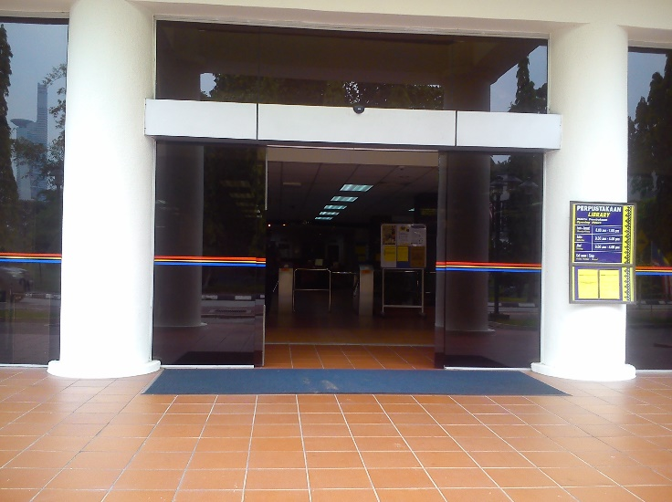

Figure 3: Main entrance of Main Library, University of Malaya

[Source: Author]

In MS 1184:2014, guiding blocks should be provided at the entrance and exits that are being used by sighted impaired students. Guiding blocks should lead the students from the parking lot to the main entrance of the library to ease the path of the impaired students. However, the observation survey, as shown in Figure 3, there are no guiding blocks anywhere near the main entrance of the library, even though the library is accessible for students with disabilities. Thus, the main entrance does not comply with the MS 1184:2014. An example of guiding blocks is as Figure 4.

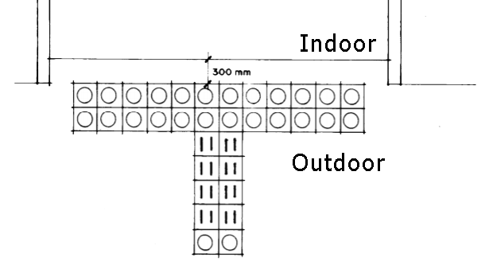

Figure 4: Guiding block for entrance

[Source: MS 1184:2014]

Lift Area & Staircase Area

Figure 5 and 6 shows the staircase area and lift area in the Main Library at the University of Malaya. As shown in the pictures, there are no guiding block places at the areas.

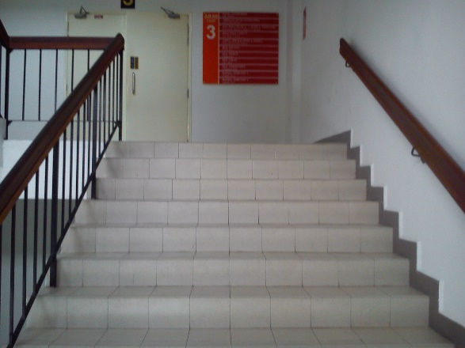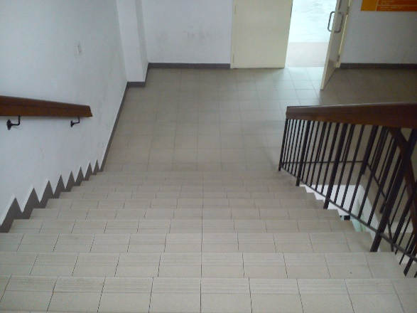

Figure 5: Main Library staircase area [Source: Author]

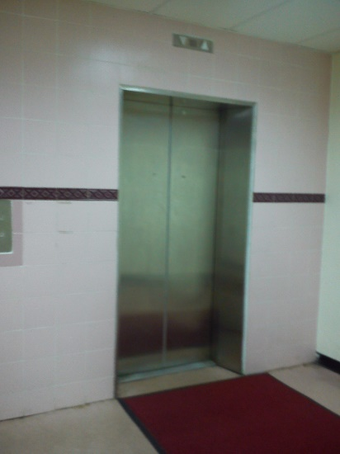

Figure 6: Main Library lift area

[Source: Author]

A detailed description on the placement of guiding blocks near stairs has was written in MS 1184:2014as shown below in Figure 7. The guiding blocks should lead the students with disabilities towards the stairs, or away from it if the destination of the students is not a level or two above him. Guiding blocks too should lead the students towards the lifts, or away from it to warn him caution of hazard. Conversely, guiding blocks are not provided around lift and stairs area. In conclusion, the lifts and stairs area does not comply with the required standard.

The lack of guiding block makes it hard for the visually impaired students to find their way around the building. This is critical because guiding blocks would alarm the impaired students of the change in level and obstacles. The installation of guiding blocks at the main entrance can help the visually impaired from running into the walls or doors, and it can caution the changes of levels in the stairs area, and any hazard ahead at the lifts area. This inadequacy can cause accidents for the visually impaired students if there is no attendant with or around him.

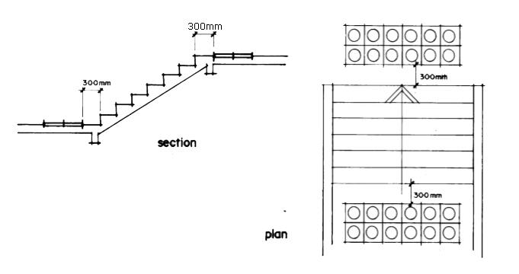

Figure 7: Guiding blocks installation [Source: MS 1184:2014]

Signs and Symbol

Signs and symbol are designed to help indicate location or direction of places and facilities, as stated in the MS 1184:2014. According to the MS 1184:2014, a sign should be appropriately sized, efficiently designed, and located in a strategic location for the benefit of the impaired students in a form of visual or audio presentation. Symbol, on the other hand, are graphically presented and is a part of signs (MS 1184:2014). The MS 1184:2014 further state that the international symbols of access should be in white with light French blue background, or vice versa, and the size varies from the required viewing distance, for example, the size of 60mm x 60mm is required for a viewing distance of 7m. According to the MS 1184:2014, the basic minimum locations of signs and symbols are the external parking lot, entrances such as main entrances, exits and emergency exits that are used by the students with disabilities, reception area, and lifts (within lifts and at lifts lobby area) and toilets.

Main Entrance

As mentioned above, one of the locations that require signs and symbols is the main entrances that are in use for the students with disabilities. The main entrance is one of the main location to have signed as it will inform not only the impaired students but also other students on the function of the space. This will give the students direction without feeling confused or hesitant to enter the library space. While doing the observation survey, as shown in Figure 8, it was found that there is proper signage for directions at the main entrance. However, there is no signs and symbols in Braille for sight impaired. As written in the MS 1184:2014, additional signs with Braille or embossed lettering should be provided for the use of the visually impaired.

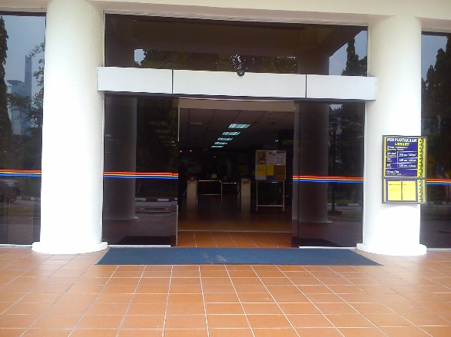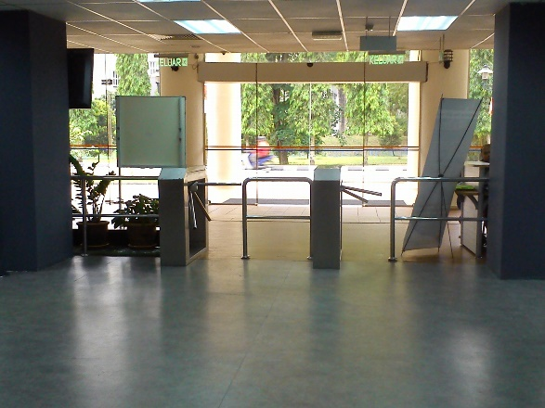

Figure 8: (Left) Main entrance of the Main Library. (Right) Entrance view to the main library space

[Source: Author]

Parking lot

Upon observation, it is identified there are no signs and symbols provided for the students with disabilities and does not fulfil the MS 1184:2014 requirements. Furthermore, the updated MS 1184:2014 stated that one (1) parking space for the disabled should be provided for every fifty (50) vehicles, with the size of the parking space should be located at the main entrance of the building, and are identifiable by symbols and signs. As shown in Figure 8, there are no signs and symbol in the parking area of the Main Library. Furthermore, there is no indication for disabled parking at the parking lot.

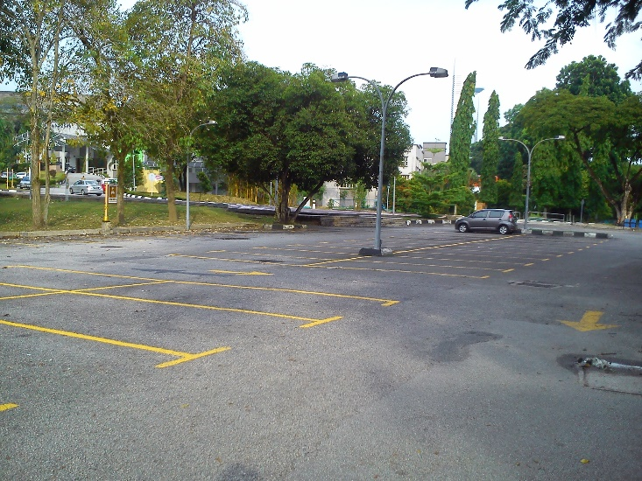

Figure 9: The Main Library of University of Malaya’s carpark area

[Source: Author]

Overall observation, the main library has lack of signage and symbols for the students with disability. Not only that, the placing of the signage is not strategic and does not have a clear indication for the use of the students with disability. The use of signage and symbols with the addition of Braille is important not only for the physical and hearing impaired students, but also the visually impaired students. This is because aside from walking stick, a visually impaired individual uses their body, such as hands to navigate themselves in a space. By having Braille to aid, it will help them to find their way around the space and direction. For that reason, the use of signage and symbols are very useful and important to be provided for a better disabled-friendly environment.

Ramp & Handrail

Equal Access (2012) define ramp as an accessible means of traversing relatively little changes in ground level. Travel along a ramp, alone or with an assistant, requires demanding effort, hence it is not appropriate for a ramp to be too steep or to raise more than a story high. MS 1184:2014 specified that a ramp gradient should not be steeper than 1:12, with a landing area, equals or nor less than 1200mm in length in the intervals of not less or equal to 6000mm, attach along a handrail on both side of the ramp.

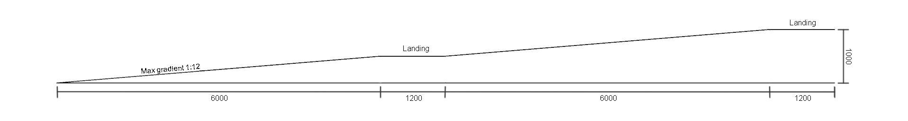

Figure 10: Ramp [Source: MS 1184:2014]

A handrail is one of the important element, not only in stairs but also in lifts, toilets, and ramps. As the MS 1184:2014 states, pathways, corridors ramps and staircases that may be accessible by wheelchair users requires handrails. The MS 1184:2014 has standardised the required set up specifically for handrail in stairs and ramps. These specifications are for the comfort of both disabled and non-disabled users. Generally, as described in MS 1184:2014, handrails should be fixed no less than 840mm or not more than 900mm from the finished floor level with no obstruction along the handgrip, together with the extension of 300mm and the ends of the handrail should turn away or tuned downwards no less than 100mm, as shown in below.

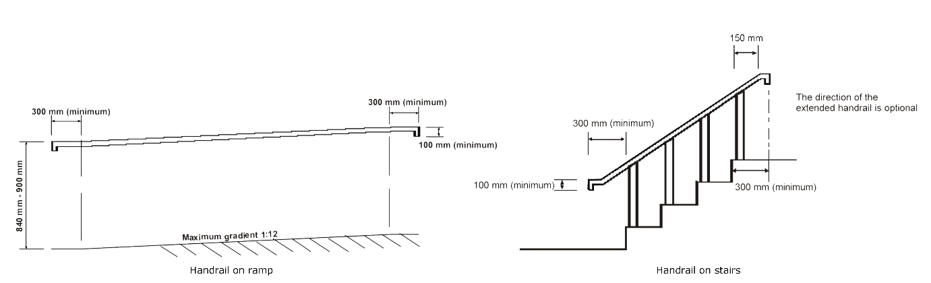

Figure 11: Handrail on ramp (Left), handrail on stairs (Right). [Source: MS 1184:2014]

Handrails on stairs and ramp should be continuous if practicable throughout each flight, or along each internal ramp or pathway and its landing and rest area. It should be fixed between 50mm to 100mm from any adjacent walls. The colour of handrails preferably contrasts to the colour of their supporting walls, and it should be able to carry a minimum load of 100kg on both sides. Finally, the grip should be in 40mm to 60mm wide in diameter and the surface provides a secure non-slip grip. Nonetheless, the handrail specification of handrails on stairs and ramp is different to handrails for lifts. Figure 10 shows the recommended ramp gradient while Figure 11 shows the recommendation for handrail on both ramp and stairs.

Ramp at Main Entrance

The observation survey has found that there is a ramp provided at the main entrance of the library for the physically impaired students and it is within the recommended width and gradient. However, as shown in Figure 12, they do not comply with MS 1184:2014, as one of the reasons is that there is no handrail provided on both sides of the ramps. As required in the MS 1184:2014, handrails on ramps and pathways used by a student with disability should be provided. This is a safety hazard that could cause accidents such as wheelchair users going off the edge of the ramp. 7.5% of the participants agree on the need for a proper ramp at the library.

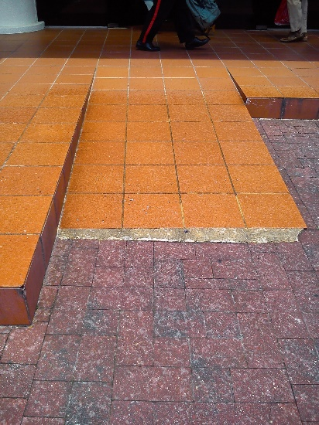

Figure 12: Ramp at main entrance

[Source: Author]

Lift Area

Based on the MS 1184:2014, at least one lifts should be designed for wheelchair users, with the handrail in the lift car should be at the height of 1000mm above the finished floor with less than 600mm long, and should be fixed adjacent to the control panel. It has been discovered that neither of the two lifts in the library provided handrails. Furthermore, the lifts are not spacious enough for wheelchair users to make a 180˚ turn, wheelchair users might have difficulties to use the control panel. Therefore, the lift area is unsuitable and is unfriendly towards persons with disabilities.

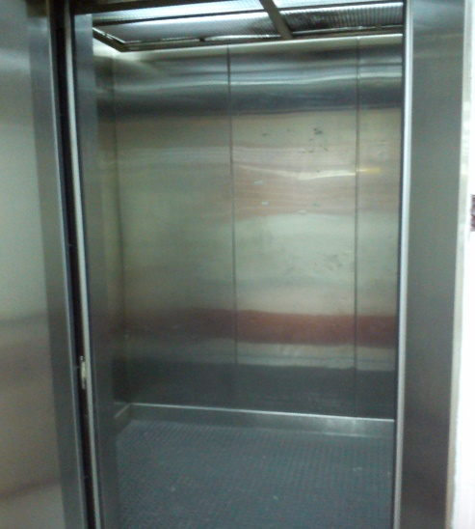

Figure 13: Main Library’s lift.

[Source: Author]

Stairs Area

A specific requirement on the handrails for stairs was written in the MS 1184:2014. The handrail must be in between 840mm to 900mm in height from the finished floor, with the extension of 300mm, and the end of the handrail should be turned away or turned downwards for at most 100mm. They should be continuous of practicable along with the landing or resting area and preferably contrast in colour from the adjacent walls.

The observation survey has found out that the handrails for the provided staircase is at a comfortable height and are accessible. However, the handrails do not have the extension of 300mm with a turned away or downward at the end of the handrail. Moreover, handrails are not provided at the landing area on the wall at the side of the door. Thus, the staircase area does not compliant with the MS 1184:2014. Another reason aside from incomplete handrail requirement, the nosing of the stairs are not provided, as required in the Malaysian Standard. According to the MS 1184:2014, the risers of the stairs should not exceed 200mm height, with the line of nosing should be at less than 300mm, with a non-slipped surface. Figure 14 shows the staircase provided at the Main Library.

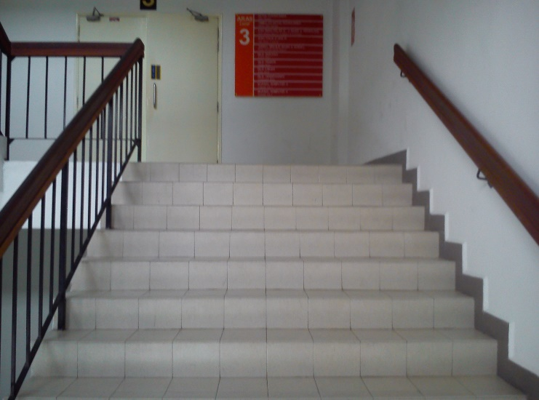

Figure 14: Handrail on staircase area

[Source: Author]

However, even though the risers and thread are in uniform and equipped with a non-slipped surface, there is no line of nosing as required. The handrail is one of the important instrument in assisting not only the students with disability but also other students. By having a proper handrail, it could prevent accidents such as falling from stairs or accidentally going down the ramp in reverse for the wheelchair users. This accidents and reasoning validate the importance of handrails for the use of all.

The conditions of the library require an attentive attention to improve their facilities. Even though it is acceptable for the students without disabilities as they are able to continue their life without these facilities, it is unacceptable to unintentionally discriminate the need for the students with disability. The improvements that should be made can improve the productivity of the students and the attitude of students towards the facilities at the same time creates a positive environment at the library.

CONCLUSIONS

Post Occupancy Evaluation was conducted at the Main Library in the University Malaya. Research regarding POE and other related topics were made, observation survey on the library was conducted, questionnaire survey and a short interview were conducted on University Malaya students with disabilities were performed. The gathered data was then analysed, understood and discussed.

Post Occupancy Evaluation (POE) is a useful tool for the use of Facility Managers to find any flaws and improvements in the building. By doing POE, the facilities can constantly be upgraded to a better infrastructure and maintain or improve the users’ satisfaction towards the building. The results of this study are significant, not only for the benefit of students with disability, for they can express their satisfaction and dissatisfactions towards the facilities provided and at the same time contribute their experiences for the betterment of the facilities, but also to the university as they can make proper maintenances and improvements on the building for the use of current and future students and staff.

ACKNOWLEDGEMENTS

This research is funded and supported by the University of Malaya Research Grant (UMRG), under the project number RP015E-15SUS.

References
Baird G., Gray J., Isscas N., Kernohan D., & McIndoe G., (1996), Building Evaluation
Techniques, McGraw-Hill, NY.
Brill M, Margulis ST, & Konar E (1985), Using Office Design to Increase Productivity,
Vol 2, Workplace Design and Productivity.
Centre for Disease Control and Prevention (2016), Disability and Health: Common Barriers
to Particiapation Experienced by People with Disabilities,
<https://www.cdc.gov/ncbddd/disabilityandhealth/disability-barriers.html>
Department of Standard Malaysia, <www.dsm.gov.my>
Equal Access, Disability Access Consultant (2002), Stairs, Ramps and Lifts,
<http://www.disabilityaccessconsultants.com.au/wp-content/uploads/2012/12/Stairs
ramps-and-lifts.pdf>
Farbstein J. & Kantrowitz M., (1989). Post-occupancy Evaluation and Organisational
Development: the experience of the United States Postal Service, in Building
Evaluation, Preiser W. (ed)., New York: Plenum Press, pg. 327.
Hastuti M. (2003), The Effectiveness of Guiding Block for the Visually Impaired,
Malioboro, Yogyakarta Indonesia.
Law of Malaysia Act 168, People with Disabilities.
Law of Malaysia (2008), Act 685, Person with Disabilities Act 2008.
Malaysian Standard (MS) 1184. (2014). Universal design and accessibility in the built environment – Code of practice (second revision). MY: Department of Standards Malaysia.
Marans RW & Spreckelmeyer K.F., (1981) Evaluating Built Environments: A Behavioural Approach, University of Michigan.
Mohd Isa, H., Zanol, H., Alauddin, K., & Nawi, M. H. (2016). Provision of disabled facilities at the Malaysian public transport station. MATEC Web of Conference, 66, 1 – 8. Retrieved from http://doi.org/10.1051/matecconf/20166600016
National Research Council, Building Research Board (1987), Post-occupancy Evaluation
Practices in the Building Process: Opportunities for improvement, National Academy Press, Washington D.C.
Preiser WFE., Rabimowit z H.Z., & White E.T., (1988), Post Occupancy Evaluation, VanNostrand Reinhold, NY.
Preiser WFE. (1989), Building Evaluation, Plenum Press, NY.
Preiser WFE. (2008), Post-Occupancy Evaluation: How to make building work better, vol.13, number 11, pg. 19-28.
United Nation Convention on the Rights of Persons with Disabilities (CRPD). (2012). The
UN convention on rights of persons with disabilities: English version, August 2012. International Paralympic Committee. Retrieved from https://www.paralympic.org/sites/default/files/document/120818093927291_2012_08+The+UN+Convention+on+Rights+of%2BPersons+with+Disabilities_ENG.pdf
United Nation Convention of the Rights of Persons with Disabilities (CRPD). (2016). The
convention on the rights of persons with disabilities: Training guide, professional training series no. 19. US: United Nations Human Rights. Retrieved from http://www.ohchr.org/Documents/Publications/CRPD_TrainingGuide_PTS19_EN%20Accessible.pdf

