EVALUATING POSSIBLE INNOVATIVE AND SUSTAINABLE APPROACH OF MOSQUE IN CONTEMPORARY WORLD
¹Nangkula Utaberta , ¹Nayeem Asif, ²Hamzah Z.
¹Faculty of Design and Architecture,  Universiti Putra Malaysia  nangkulautaberta@gmail.com | ²Jabatan Senibina,  Fakulti Kejuruteraan dan Senibina,  Universiti Kebangsaan Malaysia,  43600 Bangi, Selangor. Malaysia.
____________________________________________________________________

ABSTRACT

Mosque is one of the major establishment within a Muslim community in countries with Muslim majority as well as countries where Muslims are minority. It is almost inevitable that every Muslim community would have at least one mosque within the locality. For most of the cases in Muslim major countries, there are more than one mosque to be found in any locality. These carries the sign of different ideologies and isms of architecture according to their contextual variance. In contemporary world, where environmental issues are given high priority, identifying sustainable approach for designing mosques are strongly recommended. This paper aims to analyze the principles of Islamic teachings toward attaining a balanced built environment and its implication on developing a sustainable language for mosque architecture in contemporary world. It analyzes the indigenous characteristics of the Prophet's (pbuh) mosque and draws lessons from therein. It also presents discussion on the contemporary Polder Mosque in Netherlands and its innovative sustainable features. Recommendations are made consequently regarding sustainable approach of mosque design in the contemporary world at the end of this paper.

Keywords: Mosque, Sustainable architecture, Islamic architecture, innovative design

INTRODUCTION
Islam is the third and last monotheistic religion following the former two- Judaism and Christianity [1]⁠. As a religion, Islam offers the complete set of guidance both in spiritual and physical or social contexts. And undoubtedly from the very beginning of the religion these spiritual and physical contexts were guided through the institution of mosque, around which the lives of Muslims’ revolved as the communities grew gradually [2]⁠. Oleg Grabar marked the initial periods of the development of mosque when innovative ideas and creative thinking enabled the institution to evolve with the changing requirements of Muslim societies. Unfortunately, Later period, from twelfth century onward, the doors of innovations were closed by majority of the Muslims resulting a stagnant situation in the development and evolution of mosque [1]⁠.
Shervin Nekuee stated that, Muslims were innovative and inspiring, not introverted but out in the wide world. But today people confuse about seeking inspiration in the past with copying the past. Concrete and steel, molded into historical forms cannot conjure up the spirit of the old Islamic empire. Nostalgia is beautiful, fragile emotion, but bombastic buildings reflect only bad taste and ignorance [3]⁠. She calls for a revival in innovation, creativity, open mind and the courage to explore in order to bring back the lost glory of Islam and creative solutions to design and plan mosques with flexibility and functional variety would definitely be a step forward towards it. And this requires people with vision and imagination. These comments indicates that the 21 century mosques are recommended to be contemporized with proper vision towards attaining a sustainable language for mosque architecture. The aim of this paper is to present an elaborate discussion on the eternal idea of mosque to find out the teachings of Islam on sustainable approach towards built environment. Moreover, recommendations on sustainable practices will be made following an analysis on contemporary mosques.

PERPETUITY OF THE INSTITUTION OF MOSQUE

Robert Hillenbrand refers to the mosque as the principle religious building of Islam [4]⁠. Tajuddin Rasdi, prominent contemporary scholar on Islamic architecture, stated the same opinion with more emphasis that mosque is the most important building in Islam [5]⁠.
Spahic Omer’s comment should be noted for highlighting the significance of mosque institution in the life of Muslims. He stated that without any confusion the mosque is and always will be the center of Muslim life. He also mentioned two justification for this comment. First one being the inherent nature of man to long for worshiping its creator while the second one is man’s tendency for social interaction and communal gathering in order to solidify the bonds of society which in return secure the welfare of the individual as well as the community life [6]⁠. It should also be noted how this statement echoed the teaching of the Qur’anic verse stated before. On portraying the importance of mosque as a central institution for the Muslims, Omer combined the spiritual and the social role side by side, thus establishing the concept of Islam and mosque as its central institution in order to guide the Muslim communities toward their complete way of life. Therefore, as long as the Muslim communities exits, the institution of mosque will continue to act as a social nucleus.
Reported by Tajuddin Rasdi in his book ‘Rethinking Islamic Architecture’, Faruqi said, “today fortunately, the relevance of God to every aspect and element of space-time is being discovered by western Christendom and the repudiation of an isolated, unique, religious, holy or sacred is being prepared for. In its place, the religiousness of everything is being discovered, a religiousness that does not consist in the thing’s being a mere relatum. Islam has for centuries been teaching the religiousness of all space-time, of all life.” [7]⁠. The statement clearly announce the timelessness of Islamic teachings and its validity throughout the span of time.
Similarly, timelessness of mosque institution demands that reinterpretation of its activities and architecture to match the needs of modern Muslim societies is utterly significant. As stated by Dr. Spahic, “the mosque institution is bound to serve as a focal point of the religious and social life of the Muslims, advancing its physical stature as a guidepost and its message as an inspiration and guidance in all our development, building and planning undertakings.” [8]⁠.
Tariq Ramadan believes the principle of Islam can be translated over and over again into a form, suitable to each new context; creativity is a key role player in this regard [3]⁠.
In summary, the teaching of Islam and the practices of Prophet (pbuh) certainly are valid for any generation. It is upon that particular generation to use the imagination and creativeness of their minds, so that, they can interpret these teaching in appropriate way, applicable for their time.

LESSONS OF SUSTAINABILITY FROM EARLY MOSQUES

The Prophet's (pbuh) mosque, Al-Masjid AN-Nabawee, is an appropriate example of sustainable building practice. The most remarkable character of this mosque was its simple method of construction, using locally available materials and technology and its flexible physical layout allowing any further modifications to be undertaken without hampering the balance of surrounding nature. And this mosque opened the door for practicing mosque architecture without being biased by any per-conceived idea and apply locally available resources such as, materials, building technology and physical characteristics.
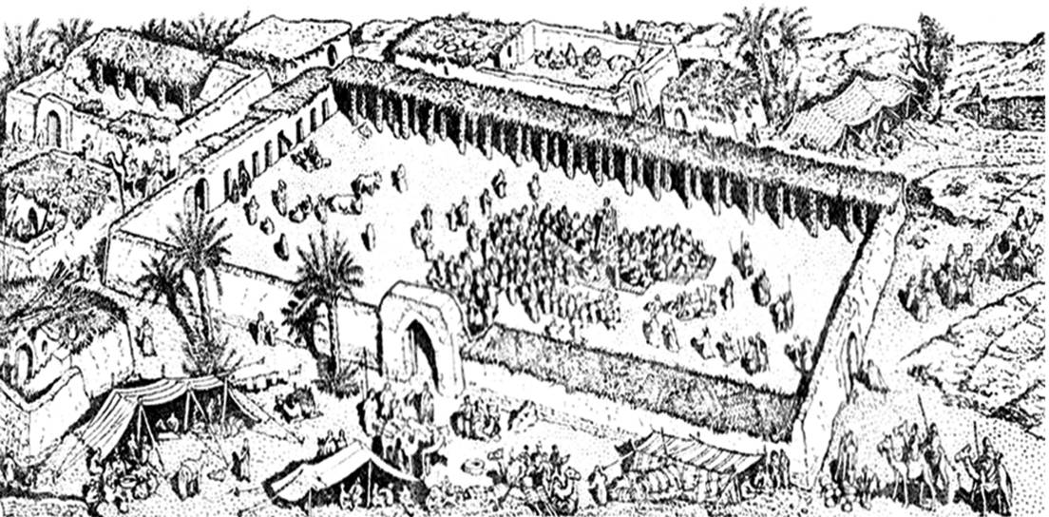

Figure 1: Prophet's (pbuh) mosque, an example of simplicity and humbleness
(Source: Nayeem Asif 2015).

Azra Akšamija argued about the preconceived formal expression for designing or defining mosques and provision for innovation. She stated, “The absence of formal definition of the mosque allows for innovation in mosque design. Yet innovation can only be possible if both architects and Muslim communities accept the foundational ideological elasticity of Islam that allows for the mosque’s formal transformation and cultural adaptability.” [3]⁠
Tariq Ramadan believes the principle of Islam can be translated over and over again into a form, suitable to each new context; creativity is a key role player in this regard. [3]⁠
In a hadith narrated by Abu Hurayra, Prophet (pbuh) clearly stated the practice of building extravagant mosque as a wrong attitude, thus prohibited in Islam. Prophet (pbuh) said, I was not commanded to build high mosques. In another hadith, Prophet (pbuh) said, one of the portents of the Day of Judgment is that you will vie with one another in building mosques [9]⁠
These hadiths echoed the Qur’anic verse prohibiting wastefulness [10]⁠. The practice of building mosque of humble expression targeted to the betterment of Muslim communities continues throughout the history of Muslim civilization until the later stumbled and started to endure decline in its numerous, if not all sections [6]⁠.
It was reported that in the Suleymaniye Complex at Istanbul, during the Umayyad Regime, the soot from candles lit in the mosques was collected and reused as ink to write [11]⁠.
From the teachings of early texts of Islam as well as the practices of early generation of Muslims, sustainable practices towards built environment were an integrated part in the ideology of the Muslims. It is only when the Muslims closed the door of innovative thinking and engaged themselves in following the traditions of the past without being sensitive towards the surrounding environment, the mosque architecture lost its sustainable character. Now, in contemporary times, the Islamic scholars once again urging for proper interpretation of Islamic philosophy. This also implies on the practitioners related with Islamic architecture to realize the inherent sustainable character of Islamic built environment as well as the needs of contemporary world to redefine the architecture of mosque suitable to this particular era.

THE ISSUE OF SUSTAINABILITY IN CONTEMPORARY MOSQUES

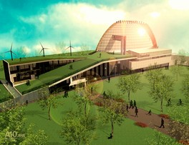
Modern world makes us able to think beyond the possibilities of traditional practices. Access to information and the extent to share it with people worldwide are now easier ever than before. Contemporary world also requires the design of the mosque to be sustainable and environmental friendly. Suggested by [12]⁠ communal mosques are recommended to be designed according to sustainable design characteristics in terms of architectural form and space. For example, maximizing day light uses, incorporating passive energy sources, use of renewable materials for construction etc. are no more a choice but strongly recommended for every mosque. Emphasizing on context based architecture [13]⁠ stated despite the fact that architects tend to use iconic elements for mosque design, the vernacular style of mosque architecture is more sensitive towards the surrounding environment. [14]⁠ suggested that the electricity supply for the mosque is recommended to be generated most economically and ecologically by applying alternative source of power. The proposed Polder Mosque in Netherlands have provision for a park to create urban breathing space for its users and wind mills as alternative source of energy [3]⁠.

Figure 2: Polder mosque, Netherlands, Incorporation of innovative technology
(Source: www.a10.eu)

Relating the idea of mosque with Frank Lloyd Wright’s concept of organic architecture [15]⁠ state that there is possibility to learn from the organic architecture of Frank Lloyd Wright in developing an alternate approach for mosque design. That study showed the close connection between the teaching of Prophet (pbuh) and the organic approach of Frank Lloyd Wright towards design. The current mosques should take this in consideration for minimizing environmental impact and the new designs for mosque are recommended to exercise the sustainable schemes as much as possible.

FINDINGS AND RECOMMENDATIONS

From the discussion above it could be noted that the sustainable practice in mosque building is not a new concept in Islam. Rather it has a deep and strong root in the practices of early periods of Muslims. These practices could be arranged into two sections- sustainable philosophy and sustainable applications.
Sustainable philosophy refers to the eternal teachings which remain unchanged and act as guideline for the practice of mosque architecture. The scope of these teachings is general in character and not limited to certain contexts or time. Among the teachings, most notable one is the prohibition of wastefulness. This put constraints to all kinds of extravagant practices that are harmful towards the nature as well as infeasible in financial aspects.
Utilization of local resources is another important teaching which ensures that the physical impact of construction as well as maintenance will be reduced to a minimum level. In contemporary terms, this will ensure a low carbon foot print in the built environment.
The sustainable applications follows these principles. Derived from these principles, it is recommended for mosque architecture to be contextual in every aspect- layout, materials, building technology and human resources. Being sensitive to the needs of the community and accommodate appropriate functions related to society are equally significant.

CONCLUSION

It is recommended for mosques to apply sustainable design schemes to minimize its impact on nature. Mosque is the center where people come to learn and practice good deeds. So a sustainable approach towards design will ensure a healthy and friendly environment for the Muslims as well as encourage them to spend more time in the mosque and participate in its activities. Moreover, people will learn to be sensitive in dealing with the environment if the interaction hub of their community i.e. the mosque itself is designed in environmental friendly way.

REFERENCES

[1] M. Frishman, H.-U. Khan, and M. Al-Asad, The Mosque: History, Architectural Development & Regional Diversity. Thames & Hudson, 2002.
[2] S. Omer, “Some Lessons from Prophet Muhammad ( SAW ) in Architecture : The Prophet’s Mosque in MadÊnah,” pp. 115–140, 2010.
[3] E. Erkoçu and C. Buğdacı, The Mosque. Political, Architectural and Social Transformations | Ergün Erkoçu, Cihan Buğdacı |. Belgium: NAi Uitgevers, 2009.
[4] R. Hillenbrand, Islamic Architecture: Form, Function, and Meaning. Columbia University Press, 2004.
[5] M. T. H. M. Rasdi, The mosque as a community development centre: Programme and architectural design guidelines for contemporary muslim societies. UK: Penerbit UTM, 1998.
[6] S. Omer, “Studies in the Islamic Built Environment,” IIUM Press, 2013. [Online]. Available: http://iiumpress.iium.edu.my/bookshop/wwwgooglecom-18. [Accessed: 11-Nov-2014].
[7] M. T. H. M. Rasdi, Rethinking Islamic Architecture. Strategic Information and Research Development Centre, 2010.
[8] N. Asif, N. Utaberta, M. Yazid, M. Yunos, N. A. Ismail, and S. Ismail, “Inactive Mosques : The Crisis of Contemporary Muslim Communities,” Adv. Environ. Biol., vol. 9, no. April, pp. 367–370, 2015.
[9] N. Asif, M. Tajuddin, M. Rasdi, N. Utaberta, and M. Yunos, “The Concept of Mosque Based on Islamic Philosophy : A Review Based on Early Islamic Texts and Practices of the Early Generation of the Muslims,” Adv. Environ. Biol., vol. 9, no. April, pp. 371–374, 2015.
[10] N. Utaberta, “Rekonstruksi Pemikiran, Filosofi Dan Perancangan Arsitektur Islam Berbasiskan Al-Qur’an Dan Sunnah,2007. Universiti Teknologi Malaysia
[11] N. Almughrabi, J. Prijotomo, and M. Faqih, “SULEYMANIYE MOSQUE : SPACE CONSTRUCTION AND TECHNICAL,” Int. J. Educ. Res., vol. 3, no. 6, pp. 345–358, 2015.
[12] N. A. Baharudin and A. S. Ismail, “Communal Mosques : Design functionality towards the development of sustainability for community,” Procedia - Soc. Behav. Sci., vol. 153, pp. 106–120, 2014.
[13] M. M. Osman, B. Hassanpour, and N. Utaberta, “A Study on African Vernacular Mosque: A Lesson from Tradition,” Appl. Mech. Mater., vol. 747, pp. 157–160, 2015.
[14] A. Mustafa, M. A. Alghoul, N. Asim, K. H. Glaisa, K. H. Abulqasem, M. N. Mohammed, A. Zaharim, and K. Sopian, “Potential of Renewable System Powering a Mosque in Libya 2 Assumptions And Model Inputs,” in Models and Methods in Applied Sciences: 2nd International Conference on Environment, Economics,Energy,Devices,Systems,Communications,Computers,Mathematics(EDSCM ’12), 2012, pp. 139–144.
[15] M. T. H. M. Rasdi and N. Utaberta, “The Design of Mosques as Community Development Centers from the Perspective of the Sunna andWright’s Organic Architecture,” J. Islam. Archit., vol. 1, no. 1, pp. 1–7, 2010.

